**Practical Assignment**

Class : Bca(AI\ML) 1B

NAME= prabhun bhandari

Group:2

Q1= **Create a simple html tag using basic tags?**

<HTML>

<HEAD>

<TITLE> HELLO WORLD </TITLE>

</HEAD>

<body>

<H1> Your Name </h1>

</Body>

</html>



Q2= **Create a web page that displays your name to the screen?**

**Ans=**

**<HTML>**

**<HEAD>**

**<TITLE> HELLO WORLD </TITLE>**

**</HEAD>**

**<body>**

**<H1> prabhun bhandari </h1>**

**</body>**

**</html>**

= output



Prabhun bhandari

**Q3= Create a web page and show the output from 1 to 10 in separate lines?**

<HTML>

<HEAD>

<TITLE> HELLO WORLD </TITLE>

</HEAD>

<body>

1<br> 2<br> 3<br> 4<br> 5<br> 6<br> 7<br> 8<br> 9<br> 10<br>

</body>

</html>

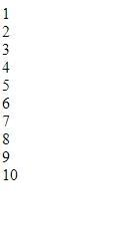 **=OUTPUT**

**Q4= Create a webpage and show the output from 1 to 10 in separate lines, each number being in different color?**

<HTML>

<HEAD>

<TITLE> HELLO WORLD </TITLE>

</HEAD>

<body>

<font color="red"> 1 </font><br>

<font color="blue"> 2 </font><br>

<font color="green"> 3 </font><br>

<font color="black"> 4 </font><br>

<font color="brown"> 5 </font><br>

<font color="pink"> 6 </font><br>

<font color="orange"> 7 </font><br>

<font color="purple"> 8 </font><br>

<font color="grey"> 9 </font><br>

<font color="yellow"> 10 </font><br>

</body>

</html>

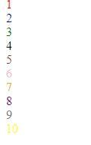  **=OUTPUT**

**Q5= how to make a picture as a background on my web pages?**

ANS= <HTML>

<HEAD>

<TITLE> HELLO WORLD </TITLE>

</HEAD>

<body>

<body background="C:\Users\student\Downloads/download.jpg">

</body>

</html>



**= OUTPUT**

**Q6=Create a web page to print a paragraph with 4-5 sentences, each sentences shall have a different font?**

**Ans=** **<html>**

**<head>**

**<title> BCA IB </title>**

**</head>**

**<body>**

**<h1>prabhun bhandari</h1>**

**<P>**

**<B>My name is prabhun bhandari.</B><br>**

**<I>I am Currently studying in manav rachna international institute of research and science. It is situated in**

**Badkhal, Faridabad. </I>**

**<br> <U> My course that i am pursuing right now is BCA(AI/ML) </U>.**

**<br><B> My Hobbies are playing games and watching movies and sometimes i go to play cricket with My friends.</B><br>**

**</p>**

**</body>**

**</html>**

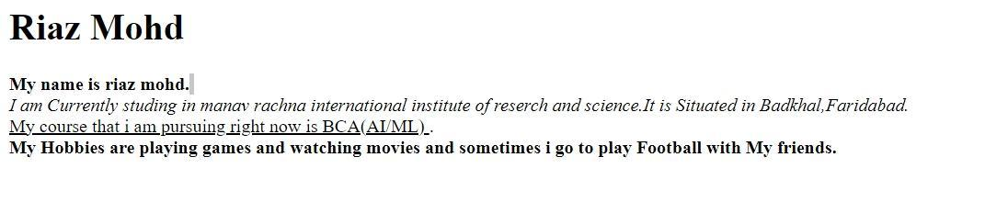

Prabhun bhandari

my name is prabhun bhandari

**= OUTPUT**

**Q7=write HTML code to print a paragraph that is described of a book, it shall include the title should be underlined and all adjectives shall be bold and italics?**

<HTML>

<HEAD>

<TITLE>BOOK </title>

</head>

<Body>

<H1><u><b> Title Of The Book: Harry potter</b></u></H1>

<p><i> Author Name: J.K Rowling <br></i>

<i>Harry Potter is a series of novels by British author J. K. Rowling. The novels follow Harry Potter,

an 11-year-old boy who discovers he is the son of famous wizards and will attend Hogwarts School of Witchcraft and Wizardry.

Harry learns of an entire society of wizards and witches. He befriends several Hogwarts students and teachers along his journey.

Each novel chronicles one year in Harry's life and

his adventures discovering the events that led to his parents' deaths at the hands of Lord Voldermort, a dark wizard believed long dead.</i></P>

</p>

</body>

</html>

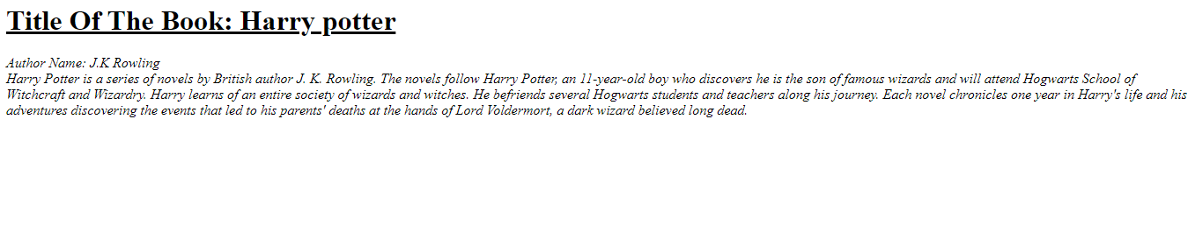

**Q8: Write HTML code to print your name using heading tag, every letter shall be of different heading size?**

**<HTML>**

**<HEAD>**

**<Title> prabhun bhandari </Title>**

**</HEAD>**

**<BODY>**

**<H1> R</h1>**

**<H2> I</h2>**

**<H3> A</h3>**

**<H4> Z</h4><br>**

**<H5> M</h5>**

**<H6> O</h6>**

**<H1> H</h1>**

**<H2> D</h2>**

**</body>**

**</html>**

**Q9:Write Html code to print the sequence of number 1-20. each no shall be in different line with number 2 next to it as subscript, an equal sign and the result?**

**Ans:** <html>

<head>

<title>Number Sequence</title>

</head>

<body>

<p>1<sub>2</sub> = 1</p>

<p>2<sub>2</sub> = 4</p>

<p>3<sub>2</sub> = 9</p> <p>4<sub>2</sub> = 16</p> <p>5<sub>2</sub> = 25</p> <p>6<sub>2</sub> = 36</p> <p>7<sub>2</sub> = 49</p> <p>8<sub>2</sub> = 64</p> <p>9<sub>2</sub> = 81</p>

<p>10<sub>2</sub> = 100</p> <p>11<sub>2</sub> = 121</p> <p>12<sub>2</sub> = 144</p> <p>13<sub>2</sub> = 169</p> <p>14<sub>2</sub> = 196</p> <p>15<sub>2</sub> = 225</p> <p>16<sub>2</sub> = 256</p> <p>17<sub>2</sub> = 289</p> <p>18<sub>2</sub> = 324</p> <p>19<sub>2</sub> = 361</p> <p>20<sub>2</sub> = 400</p> </body>

</html>

Output:

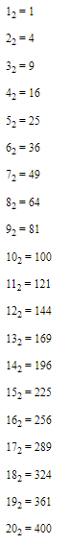

Q10. wtrite an html code to display an image with border of size with width 200 height 200 pixels , leaving Hspace and Vspace of your choice with image hanging in the right side on the screen.

Ans: <HTML>

<head>

<title>Image Display</title>

<style>

img {

border: 2px solid black;

width: 250px;

height: 250px;

display: block;

margin-left: auto;

margin-right: 0;

margin-top: 20px;

margin-bottom: 20px; }

</style>

</head>

<body>

<img src="C:\Users\student\Downloads/jerry-zhang-nxu_VUcBVdA-unsplash.jpg" alt="Sample Image">

</body>

</html>

Output:

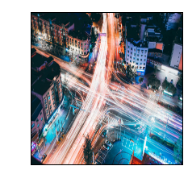

Q11: write a html code to create a web page with heading. the heading shall be displayed at the top-centre of the page and the image shall be at the centre , just below the heading .

INPUT- <html>

<head>

<title>Centered Heading and Image</title>

<style>

body {

margin: 0;

font-family: Arial, sans-serif;

text-align: center;

justify-content: center;

align-items: center;

</style>

</head>

<body>

<h1>The Triumph of India 2024</h1>

<img src="C:\Users\prabhun\Downloads/prabhun.jpg" alt="scenery" height="450" , width='450'>

</body>

</html>

Output:

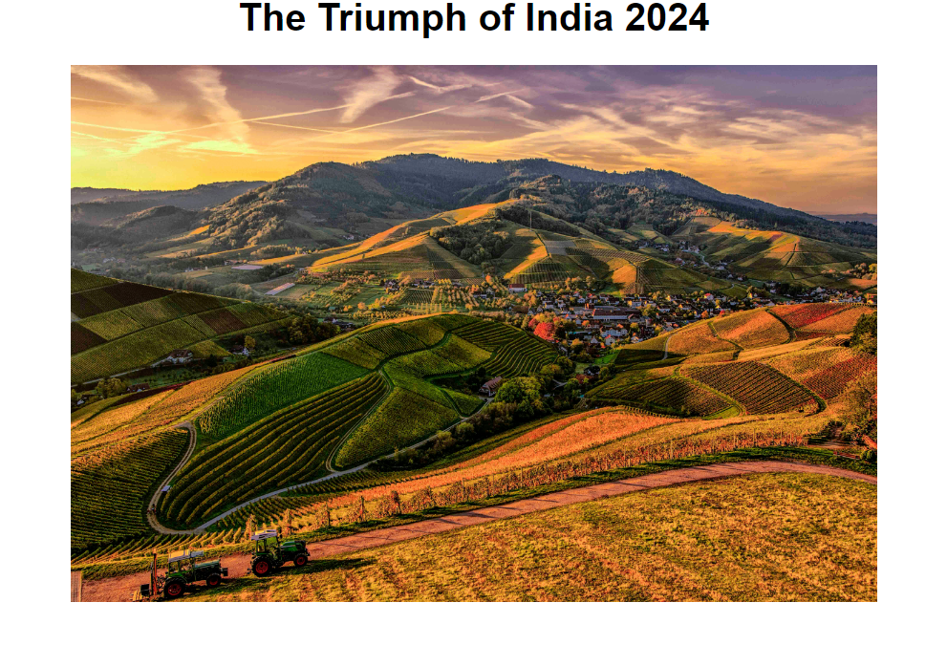

Q12. Write HTML code using Multimedia tags.

<html>

<head>

<title> multimedia tags</title>

</head>

<body>

<h1> multimedia tags: </h1>

<h1>img</h1>

<center>

<img src="C:\Users\prabhun\Downloads/prabhun.jpg" alt="scenery" height="450" , width="450"/>

<h1> audio </h1>

<audio src="C:\Users\prabhun\Downloads/ringtone.mp3" controls/>

</body>

</html>

Output:

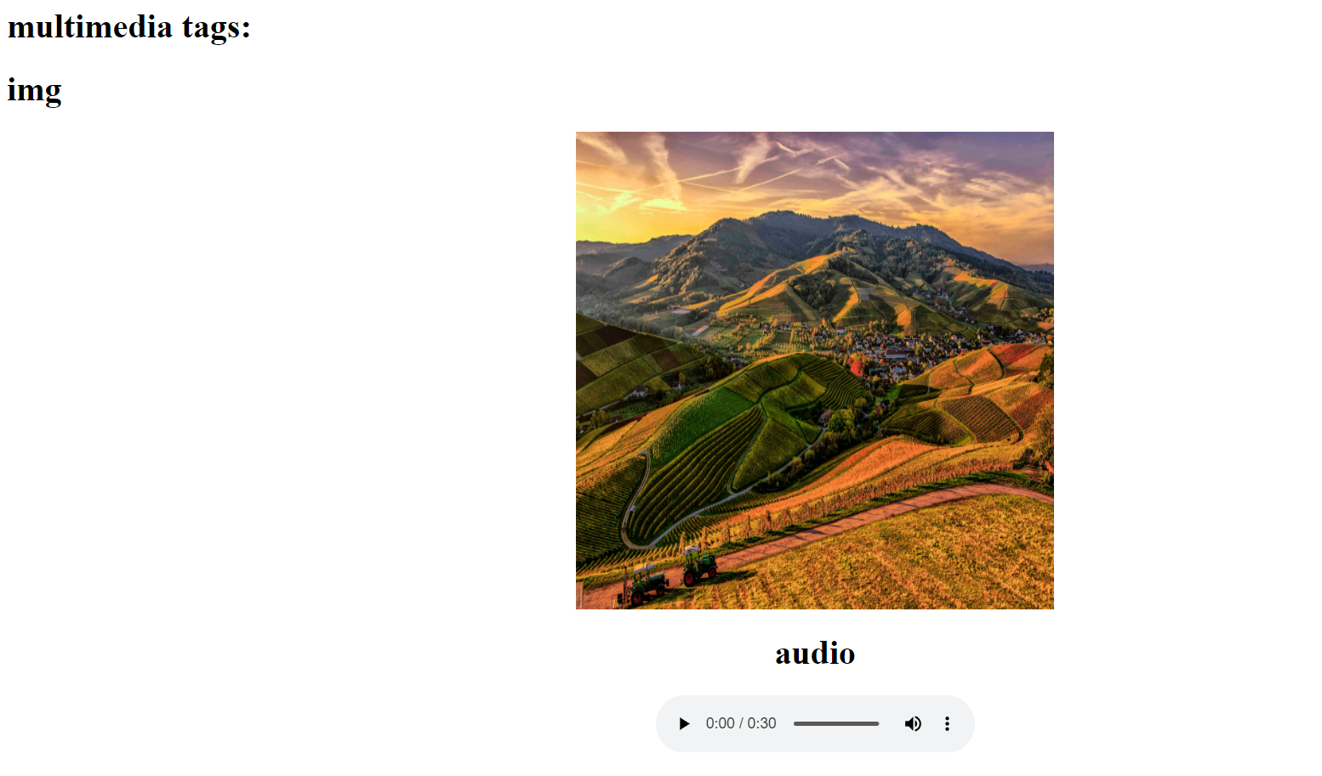

**Video tag:**

**<html>**

**<head>**

**<title> multi media tags</title>**

**</head>**

**<body>**

**<video src="C:\Users\prabhun\Downloads/vidio.mp4" width="720" heigth="480" alt="vidio" controls="control">**

**</video>**

**</body>**

**</html>**

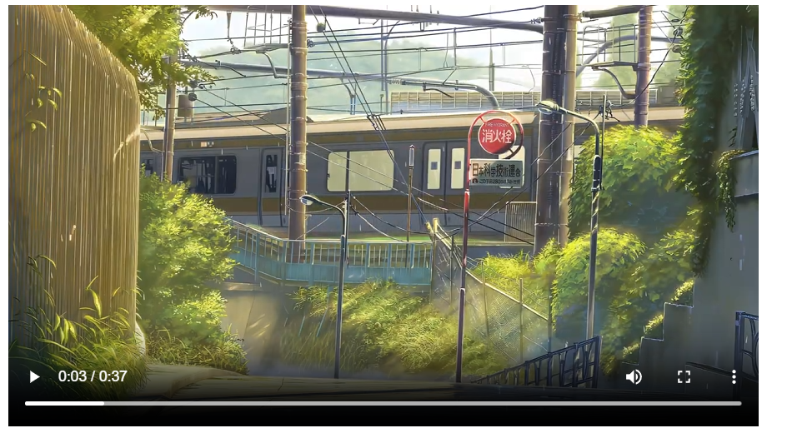

**Q13:** **Create a Table using Rowspan and Colspan taking example of student Record?**

**Ans:**

1. **rowspan**

**<html>**

**<head>**

**<title> my world </title>**

**</head>**

**<body>**

**<h1> table </h1>**

**<table border="2">**

**<tr>**

**<th> name</td>**

**<th> roll no</td>**

**</tr>**

**<tr>**

**<td >prabhun</td>**

**<td rowspan="2">060</td>**

**</tr>**

**<tr>**

**<td> kavya</td>**

**<td rowspan="2">51</td>**

**</tr>**

**</table>**

**</body>**

**</html>**

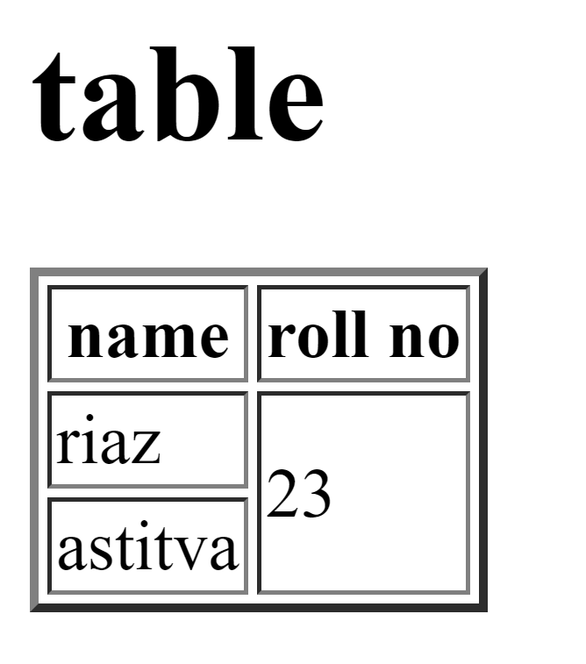

prabhun

kavya

hh

060

051

Colspan:

<html>

<head>

<title> my world </title>

</head>

<body>

<h1> table </h1>

<table border="2">

<tr>

<th> name</td>

<th> roll no</td>

<th> class</th>

</tr>

<tr>

<td >prabhun</td>

<td colspan="2">060</td>

</tr>

<tr>

<td>kavya</td>

<td>51</td>

<td> bca </td>

</tr>

</table>

</body>

</html>

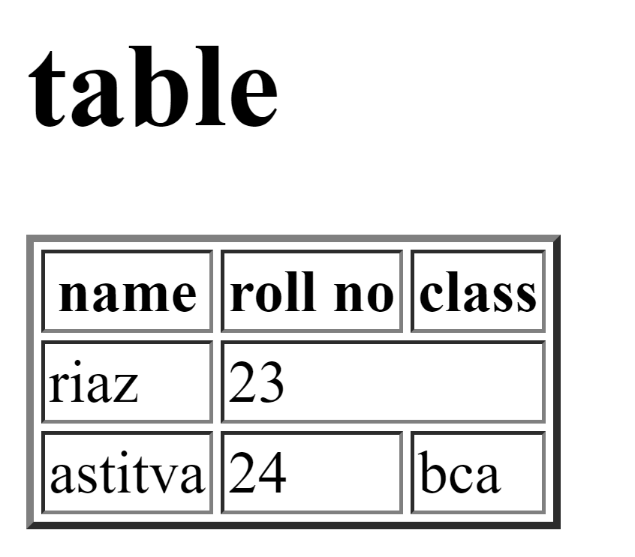

prabhun

kavya

060

051